Adding additional content with factors that influence Round trip time.

Link : <https://wiki.developer.mozilla.org/en-US/docs/Glossary/Round_Trip_Time_(RTT)>

**Original Source Document.**

<p><strong>Round Trip Time (RTT)</strong> is the length time it takes for a data packet to be sent to a destination plus the time it takes for an acknowledgment of that packet to be received back at the origin. The RTT between a network and server can be determined by using the <code>ping</code> command.</p>

<div>

<pre class="brush: unix">

$ ping example.com

PING example.com (216.58.194.174): 56 data bytes

64 bytes from 216.58.194.174: icmp_seq=0 ttl=55 time=25.050 ms

64 bytes from 216.58.194.174: icmp_seq=1 ttl=55 time=23.781 ms

64 bytes from 216.58.194.174: icmp_seq=2 ttl=55 time=24.287 ms

64 bytes from 216.58.194.174: icmp_seq=3 ttl=55 time=34.904 ms

64 bytes from 216.58.194.174: icmp_seq=4 ttl=55 time=26.119 ms

--- google.com ping statistics ---

5 packets transmitted, 5 packets received, 0.0% packet loss

round-trip min/avg/max/stddev = 23.781/26.828/34.904/4.114 ms</pre>

<p>In the above example, the average round trip time is shown on the final line as 26.8ms.</p>

</div>

<h2 id="See_Also">See Also</h2>

<ul>

<li><a href="/en-US/docs/Glossary/time_to_first_byte">Time to First Byte (TTFB)</a></li>

<li><a href="/en-US/docs/Glossary/Latency">Latency</a></li>

</ul>

**Content and factors I will be adding**

How does round-trip time work?

Let’s say there is a user in new York that is making a request for a website, the network traffic is then transferred across many different routers in different physical locations before terminating at the server in Singapore, the server from Singapore then responds from the internet to the location where user is located in our case new York.  
Once this request comes back and terminates at the users location, we can then estimate the time it took or round trip between the two locations.

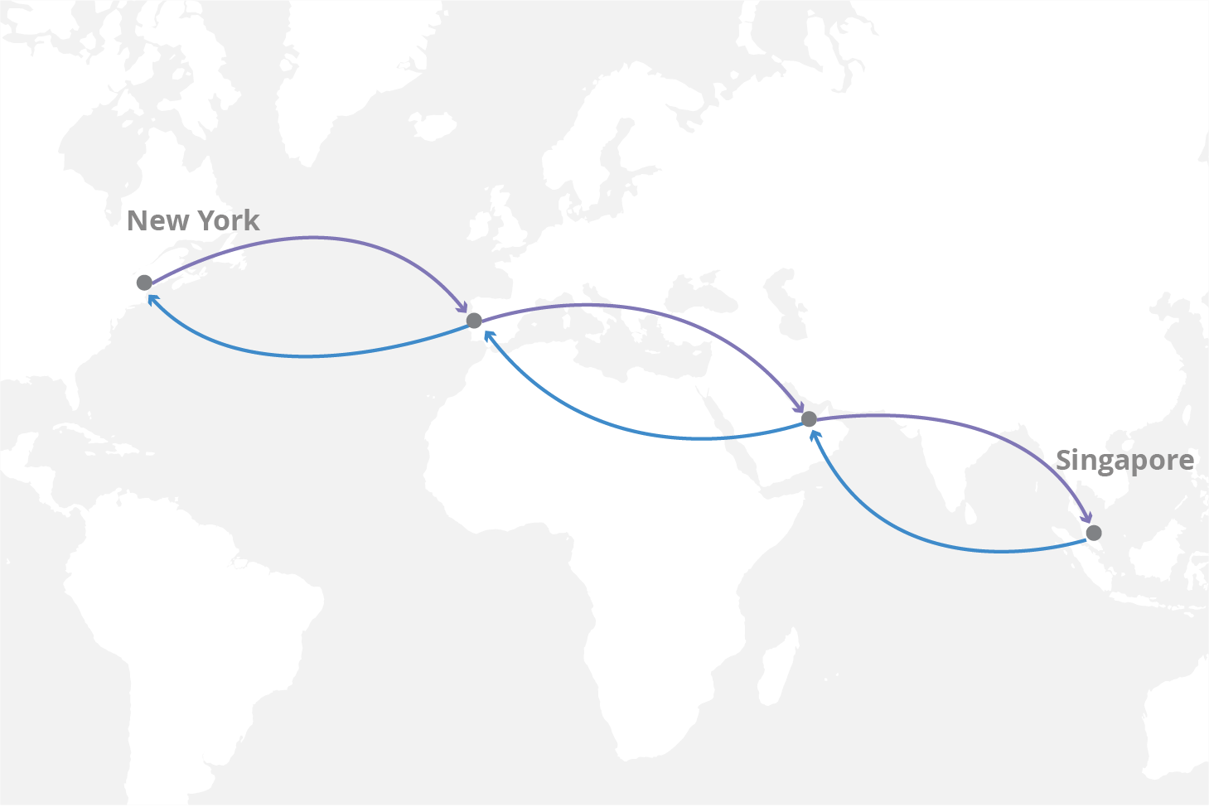

Note : Round trip time is just an estimate not an exact amount of time; the time between the two locations can keep changing as there are many other factors to be considered here as network congestion. Below I have listed a few factors that affect Round trip time.

* Physical Distance : the distance between the two endpoints is a limiting factor in network connectivity that can only be reduced by moving content closer to the requesting users.
* Traffic levels : Round Trip Travel time will increase when a network is congested with high levels of traffic. Low traffic will decrease the round-trip travel time.
* Network hops: if a request has to go through many routers or intermediate servers to reach its destination, this will lead to more Round-trip time.
* Medium : the medium that is being used to transfer the request or route the signal (e.g., copper wire, fibre optic cables).
* Server processing time : if a server is processing multiple or a high volume of request at a time, this would increase the processing time which in case would increase the Round trip time.

**After adding content and factors to Source document.**

|  |
| --- |
| <p><strong>Round Trip Time (RTT)</strong> is the length time it takes for a data packet to be sent to a destination plus the time it takes for an acknowledgment of that packet to be received back at the origin. The RTT between a network and server can be determined by using the <code>ping</code> command.</p>  <pre class="brush: unix">  $ ping example.com  PING example.com (216.58.194.174): 56 data bytes  64 bytes from 216.58.194.174: icmp_seq=0 ttl=55 time=25.050 ms  64 bytes from 216.58.194.174: icmp_seq=1 ttl=55 time=23.781 ms  64 bytes from 216.58.194.174: icmp_seq=2 ttl=55 time=24.287 ms  64 bytes from 216.58.194.174: icmp_seq=3 ttl=55 time=34.904 ms  64 bytes from 216.58.194.174: icmp_seq=4 ttl=55 time=26.119 ms  --- google.com ping statistics ---  5 packets transmitted, 5 packets received, 0.0% packet loss  round-trip min/avg/max/stddev = 23.781/26.828/34.904/4.114 ms</pre>  <p>In the above example, the average round trip time is shown on the final line as 26.8ms.</p>  <h2>How does round-trip time work?</h2>  <p>Let’s say there is a user in new York that is making a request for a website, the network traffic is then transferred across many different routers in different physical locations before terminating at the server in Singapore, the server from Singapore then responds from the internet to the location where user is located in our case new York.<br />  Once this request comes back and terminates at the users location, we can then estimate the time it took or round trip between the two locations.</p>  <p><img alt="Round trip time - Example" src="https://www.cloudflare.com/img/learning/cdn/glossary/round-trip-time-rtt/round-trip-time-rtt-map.png" style="height:800px; width:1198px" /></p>  <div class="blockIndicator note" role="complementary">  <p>Round trip time is just an estimate not an exact amount of time; the time between the two locations can keep changing as there are many other factors to be considered here as network congestion. Below are&nbsp;a few factors that affect Round trip time.</p>  </div>  <p></p>  <h2>factors affecting round trip time</h2>  <ul>  <li>Physical Distance : the distance between the two endpoints is a limiting factor in network connectivity that can only be reduced by moving content closer to the requesting users.</li>  <li>Traffic levels&nbsp;: Round Trip Travel time will increase when a network is congested with high levels of traffic. Low traffic will decrease the round-trip travel time.</li>  <li>Network hops: if a request has to go through many routers or intermediate servers to reach its destination, this will lead to more Round-trip time.&nbsp;&nbsp;&nbsp;&nbsp;&nbsp;&nbsp;&nbsp;&nbsp;&nbsp;&nbsp;&nbsp;&nbsp;&nbsp;&nbsp;&nbsp;&nbsp;&nbsp;&nbsp;&nbsp;&nbsp;&nbsp;&nbsp;&nbsp;&nbsp;&nbsp;&nbsp;&nbsp;&nbsp;&nbsp;&nbsp;&nbsp;&nbsp; &nbsp;</li>  <li>Medium used for transmission :&nbsp; the medium that is being used to transfer the request or&nbsp; route the signal (e.g., copper wire, fibre optic cables)</li>  <li>Server processing time : if a server is processing multiple or a high volume of request at a time, this would increase the processing time which in case would increase the Round trip time.</li>  </ul>  <h2 id="See_Also"><br />  See Also</h2>  <ul>  <li><a href="/en-US/docs/Glossary/time_to_first_byte">Time to First Byte (TTFB)</a></li>  <li><a href="/en-US/docs/Glossary/Latency">Latency</a></li>  </ul> |

**Preview after making changes to the Document.**

